http://www.nationalparksblog.com/best-hike-at-goblin-valley-state-park-utah/

Best Hike at Goblin Valley State Park Utah

Posted on September 30, 2011

Print Email

While there are a number of trail hikes at Goblin Valley state park (Curtis Bench Trail, Entrada Canyon Trail, and Carmel Canyon Trail), the best hike at Goblin Valley state park isn’t a marked trail at all. One of the wonderful aspects about Goblin Valley is that you can wander into the valley among all the goblins and explore to your heart’s content creating your own hike. Since the Observation Point makes for an easily recognizable orientation point, you don’t have to worry about getting lost or turned around as you wander.
As soon as you make your way down into the valley, you’re greeted with the goblins at eye level:
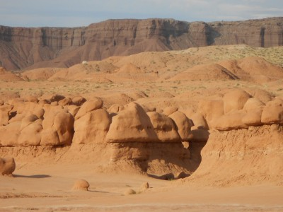
What makes wandering the valley so much fun is that around every corner there are more goblins hidden around unseen side valleys:
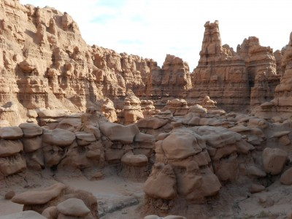
Hiking among the goblins also lets you see how playful they can be:
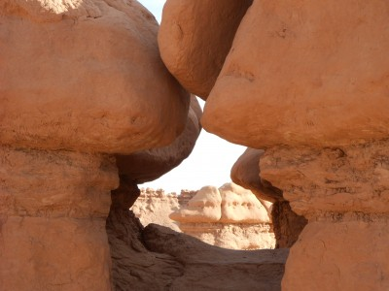
There are actually three valleys which you can explore (be sure to take plenty of water) meaning that it is easy to spend hours wandering while seeing new goblin formations. For those that like to wander instead of following a preset path when hiking, this is definitely a destination you want to add to your list.
This entry was posted in State Parks and tagged best hike goblin valley, Goblin Valley, Goblin Valley hiking, Utah state park. Bookmark the permalink.

← Black Bear Cub Opens Car Door Great Smoky Mountains National Park

